Antenna Filter Circuit Tuning

Objective
The purpose of this document is to document the process of tuning the filter for both the F-Inverted, and SMA connected Antenna. The tuning was conducted using both the NanoVNA and ADS software. The trace line widths for the antenna circuit were calculated using the KiCad Trace Impedance Calculator.

Specifications
- Operational Frequency Range: 2.4 GHz - 2.5 GHz
- Desired Return Loss: -40 dB

Solution
The initial filter topology design with values was acquired from the QPG6200L’s datasheet.
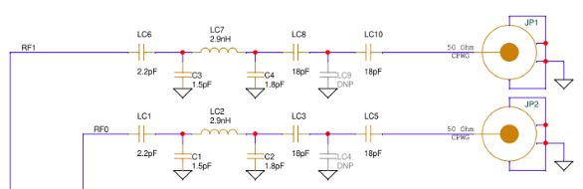
Figure 1: QPG6200L Filter Design

This filter was recreated in KiCad and utilized for the first renditions of the PCB design. The NanoVNA was utilized to test the S11 Impedance, Return Loss, VSWR, and other variables at the 2.4 GHz to 2.5 GHz frequency band. The following figures display this data.

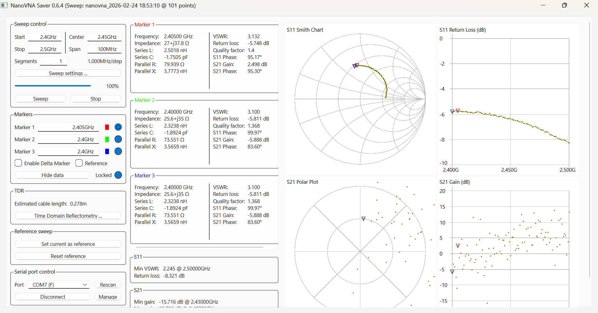
Figure 2: NanoVNA Table 1

Figure 3: NanoVNA Table 2


Figure 4: NanoVNA Return Loss Plot

Figure 5: NanoVNA Smith Chart Plot

The Circuit was then reconstructed in ADS to tune the Impedance and return loss to the desired specifications.
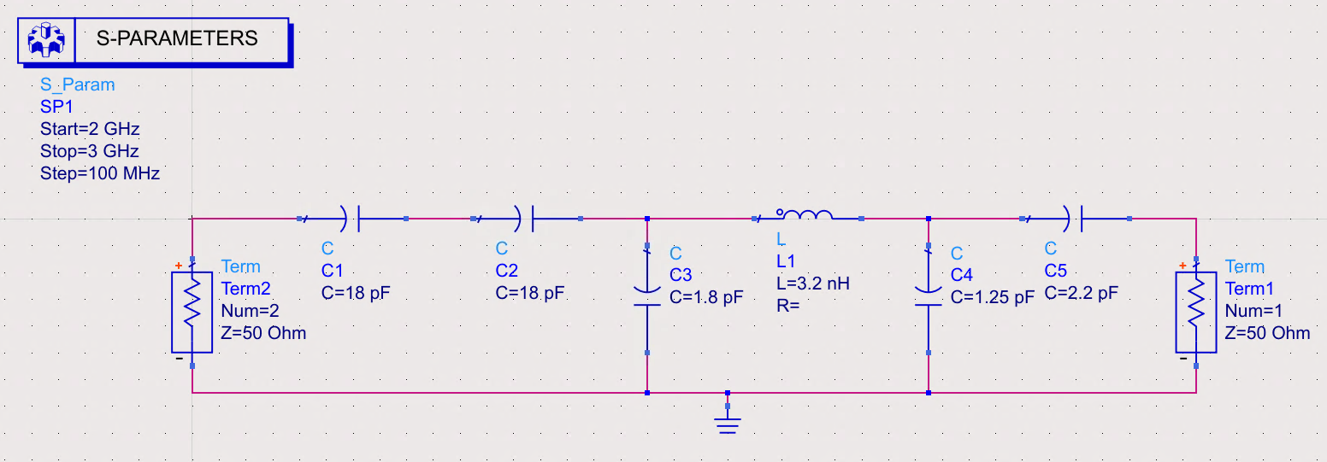
Figure 6: ADS Filter redesign

The following circuit was then simulated and the following Impedance and Return loss were obtained.

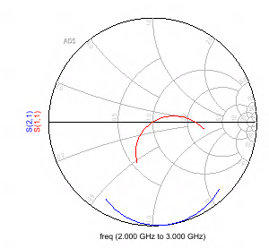
Figure 7: ADS Impedance Plot

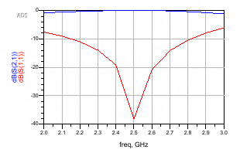
Figure 8: ADS Return Loss Plot

The L1 inductor and C4 capacitor were altered to achieve the near 50 Ohm S11 impedance and -38 dB Return loss at 2.5 GHz.

Parts List
- LQG15WZ3N2C02D 3.2 nH Inductor
- CBR06C129B5GAC 1.2 pF Capacitor

Trace width calculation
The trace widths for the antenna circuit were initially calculated to meet JLC PCB manufacturing specifications. After the last minute switch to OSH Park the recalculation of trace widths was missed for the first 2 board orders. The trace widths were recalculated using the KiCad trace width calculator tool.

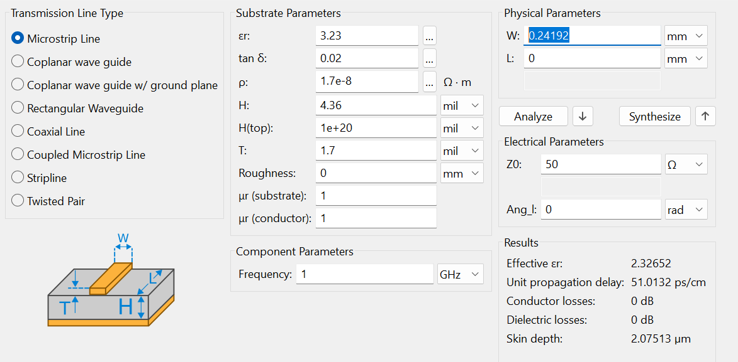
Figure 9: KiCadTrace Width Calculator

